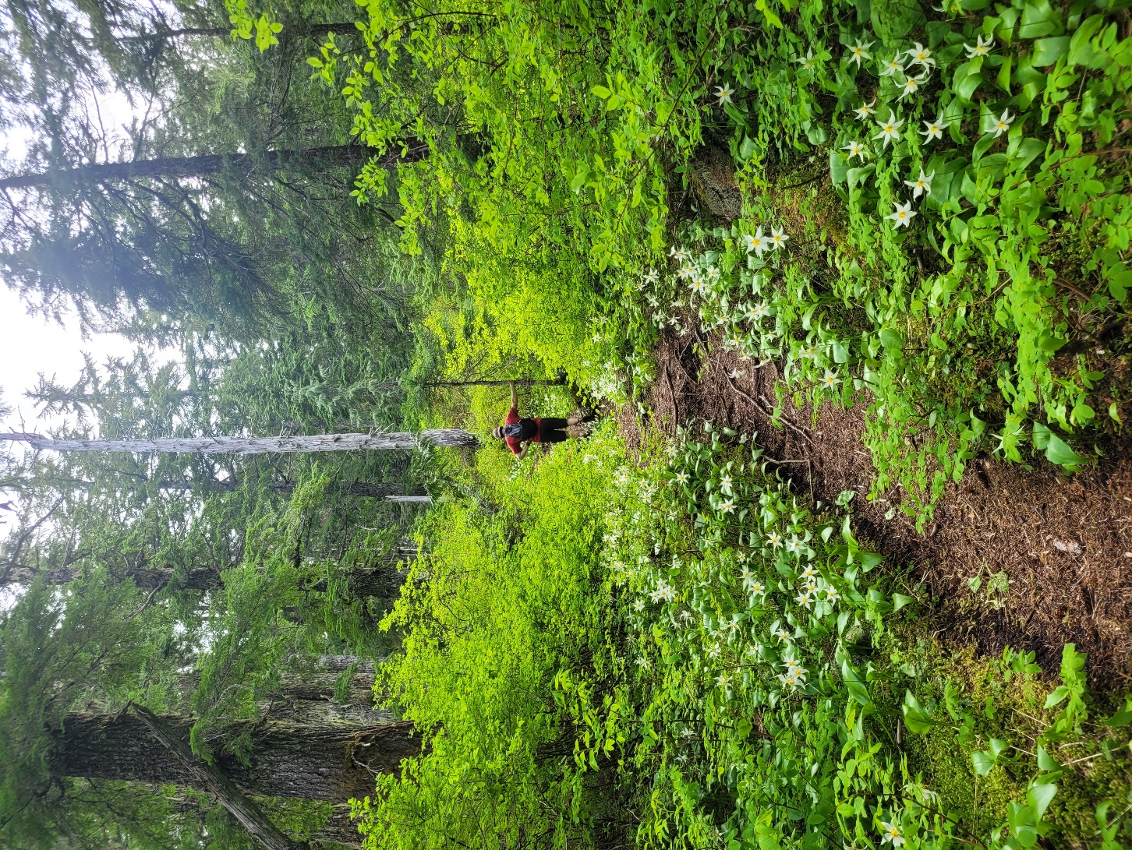

Scope document

FLoRa Outdoor Communications

06 September 2024

Rev 1.1

Aaron Huinink

Tella Osler

Cameron Gillingham

# Concept

A low-cost, low-power, user-friendly LoRaWAN-based wilderness point-to-point network to be used in places without cellular coverage and without the need for expensive satellite communication devices.

# Requirements

1. Repeater nodes with LoRaWAN capabilities and webapp accessible through the ESP32 Wi-Fi access point for users to interface with the network.
2. Off-grid capability with solar power and battery charging.
3. Antenna connections for the LoRaWAN transmissions.
4. Forward-compatibility with future development of cellular gateway end node.

# Scope

## Justification & Purpose

Back-country activities come with inherent risks. The lack of cell coverage in remote wilderness locations limits communication methods to expensive satellite devices like Garmin InReach. As backcountry enthusiasts ourselves, we seek to provide an affordable, user-friendly alternative to these satellite devices in locations that implement our network.

## Boundaries

Because Wi-Fi has limited range, our network will only be accessible by trail users who are within Wi-Fi range of the network access points. The links between access points are established using the LoRaWAN data, transport, and physical layers which is very resilient to noise but works best with line-of-sight transmission. We will carefully select locations for repeaters and access points ensuring reliable link transmissions which means the access points will be geographically fixed. Therefore, people in the area who want to use the network will have to go to the access point locations.

## Strategy

We will manage our project using a Kanban-style project in our organization’s GitHub. Everything will be version controlled and we will assign roles and responsibilities to group members within the project. We have scheduled regular weekly meetings to discuss progress and everything except personal journals will be version controlled by the organization’s GitHub.

## Deliverables

Repeater enclosures containing the hardware, firmware, and software necessary to meet the project requirements in a mock test environment based on our reconnaissance done this summer on the Kludahk trail.

## Acceptance Criteria

We will have a prototype network of 3 or more nodes that fulfills our deliverables in a mock test environment based on our reconnaissance missions to the Kludahk Trail this summer.

## Constraints

Our main constraint will be financial. We are self-funding because RF, solar, and power storage equipment is expensive and would immediately require us to petition for additional funding, and we would like to keep our prototypes at the end of the semester to potentially install in a real-world scenario.

## Assumptions

1. Users will not use the network for nefarious purposes. They will not rely on the network as their primary and only lifesaving communication method.
2. We have full support from Camosun and will receive guidance from faculty members when appropriate.
3. Billable work hours budgeted (40 hours/week/member) will be enough to complete the project.
4. We can afford all the batteries we will need to reliably supply power to the repeater nodes in seasons with less insolation.

## Budget Estimate

### Financial

All estimates are within an order of magnitude using the Fermi Estimation technique.

|  |  |  |  |  |
| --- | --- | --- | --- | --- |
| **Category** | **Unit** | **Unit Cost ($)** | **Quantity** | **Sub Total ($)** |
| Processing | ESP32 | 1 | 5 | 5 |
| SD Flash | 10 | 5 | 50 |
| RF | Lora Transceiver | 10 | 5 | 50 |
| Coax | 100 | 2 | 200 |
| Connectors | 10 | 30 | 300 |
| Antennas | 100 | 5 | 500 |
| Power | Solar panels | 10 | 10 | 100 |
| Batteries | 10 | 10 | 100 |
| Enclosures | 100 | 5 | 500 |

|  |  |
| --- | --- |
| **TOTAL** | **$1805** |
| PER PERSON | $600 |

### Labour

|  |  |  |
| --- | --- | --- |
| **Member** | **Hours** | **Cost** |
| Aaron Huinink | 560 | $0 |
| Tella Osler | 560 | $0 |
| Cameron Gillingham | 560 | $0 |

## Stakeholders

Group members and the Kludahk Trail Club as a potential beneficiary of the project in the future.